## Reports/ Rx Reports/ Emergency Fill Report

Request:

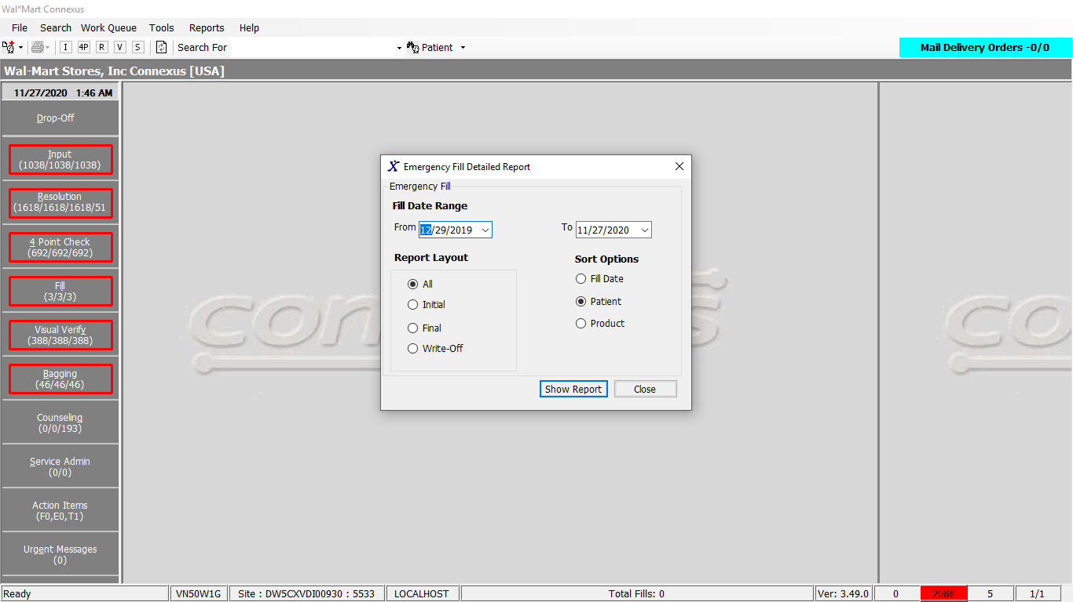

Response:

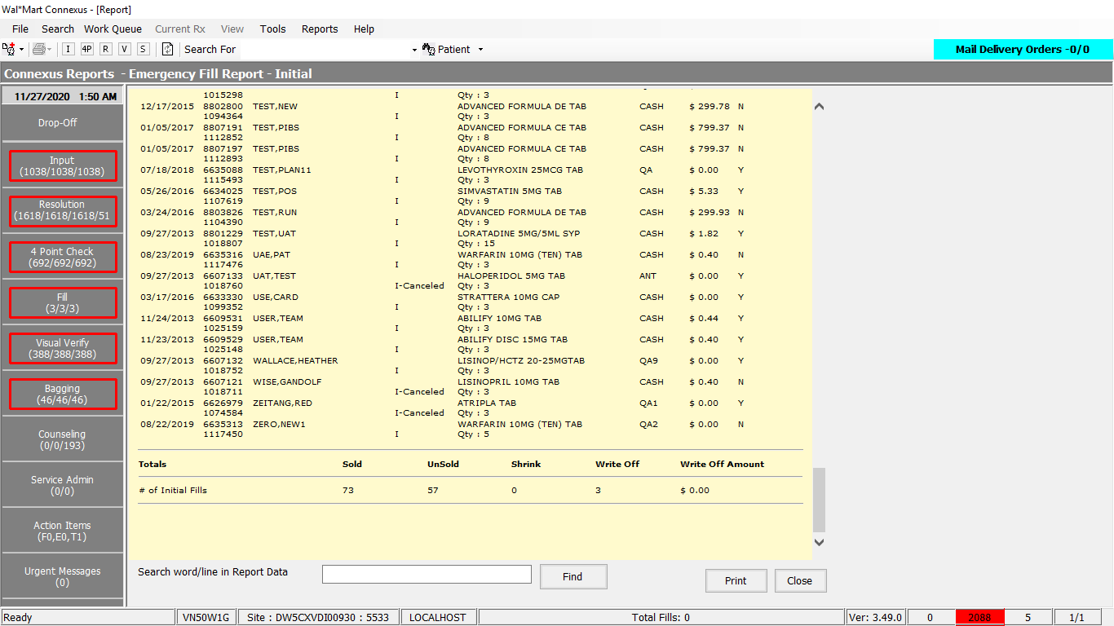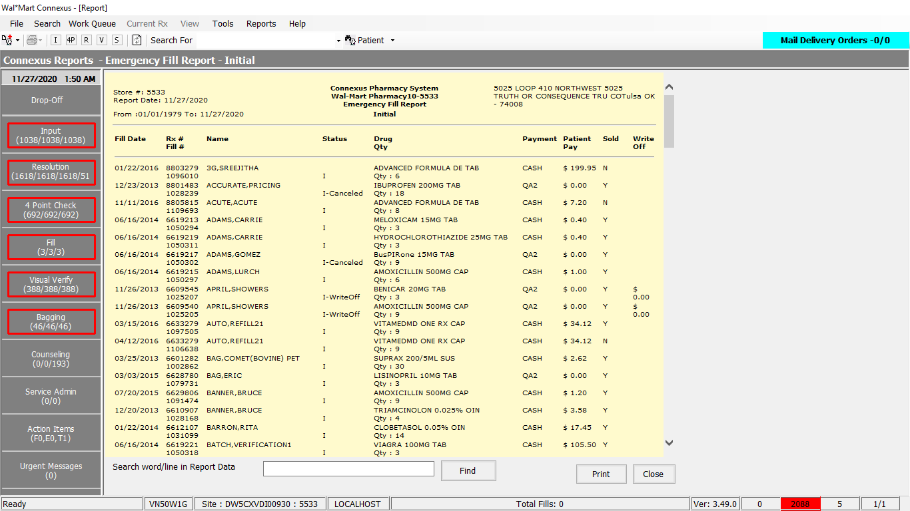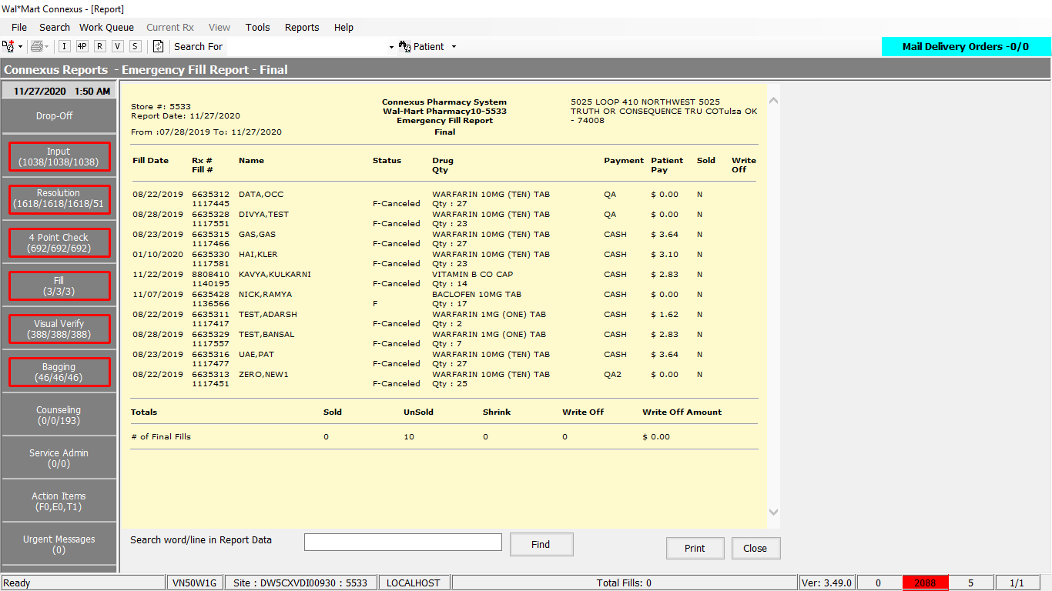

Queries:

1. Friend Const GetEmergencyFillReportPart1 As String = "SELECT rx_nbr,rxf.fill_date,rxf.rx_fill_id,TRIM(NVL(pat.last_name,'')) || ',' || TRIM(NVL(pat.first_name,'')) || ' ' || TRIM(NVL(pat.middle_name,'')) Name,rxf.fill_type_code,rxf.fill_qty,CASE WHEN rx.compound_ind = 'N' THEN TRIM(pp.short_name)WHEN rx.compound_ind = 'Y' THEN TRIM(co.compound_name) END drug_name, (SELECT phm_co_name_abbr FROM phm_company WHERE phm_co_id = (SELECT aff_party_id FROM rx_sale_detail rsd WHERE rsd.rx_fill_id = rxf.rx_fill_id AND rsd.txn_type_code = ? AND rsd.status_code IN (?,?,?,?))) TP, rxf.patient_due_amt,rx.rx_check_userid,rxf.rph_of_rec_userid,rxf.pos_ts,rxf.third_party_ind,rxf.status_code,CASE WHEN rxf.fill_type_code = 7002 THEN (SELECT rxf1.status_code FROM partial_fill pf,rx_fill rxf1 WHERE pf.init_partl_fill_id = rxf.rx_fill_id AND pf.init_partl_fill_id = rxf1.rx_fill_id AND rxf1.rx_fill_id = rxf.rx_fill_id) WHEN rxf.fill_type_code = 7003 THEN (SELECT rxf1.status_code FROM partial_fill pf,rx_fill rxf1 WHERE pf.fnl_partl_fill_id = rxf.rx_fill_id AND pf.fnl_partl_fill_id = rxf1.rx_fill_id AND rxf1.rx_fill_id = rxf.rx_fill_id) END part_status_code,rxf.pos_sale_amt,rxf.rx_id,rxf.rx_fill_seq_nbr FROM rx, OUTER (rx_compound rxc, compound co), patient pat, rx_fill rxf, rx_fill_item rfi, pharmacy_offering:pharmacy_item pi, pharmacy_offering:pharmacy_product pp WHERE rxf.rx_id = rx.rx_id AND rxf.rx_version_seq_nbr = rx.rx_version_seq_nbr AND rx.patient_id = pat.patient_id AND rfi.rx_fill_id = rxf.rx_fill_id AND ("

2. Friend Const GetEmergencyFillReportPart2 As String = "SELECT NVL(MAX(rf2.rx_fill_id),0) FROM rx_fill rf2 WHERE rf2.fill_type_code = ? AND rf2.emergency_fill_ind = 'Y' GROUP BY rf2.rx_id,rf2.rx_fill_seq_nbr"

3. Friend Const GetEmergencyFillReportPart3 As String =

"AND rxf.fill_date >=? " _

& " AND rxf.fill_date <=? " _

& " AND rxc.rx_id = rx.rx_id" _

& " AND co.compound_id = rxc.compound_id" _

& " AND pi.product_mds_fam_id = pp.product_mds_fam_id" _

& " AND rfi.item_mds_fam_id = pi.mds_fam_id" _

& " AND rfi.item_seq_nbr = (SELECT NVL(MIN(rfi2.item_seq_nbr),1) " _

& " FROM rx_fill_item rfi2 " _

& " WHERE rfi2.rx_fill_id = rfi.rx_fill_id) AND rxf.emergency_fill_ind = 'Y' GROUP BY 1,2,3,4,5,6,7,8,9,10,11,12,13,14,15,16,17,18 "

DAL:

Public Function GetEmergencyFillReport(ByVal siteId As Integer,

ByVal startDate As Date,

ByVal endDate As Date,

ByVal reportLayout As Integer,

ByVal sortOrder As Integer) As List(Of GetPartialFillReportInfoBE) Implements IReportDAL.GetEmergencyFillReport

Using (New Tracer(ConnexusCommonConstants.ConnexusTracer))

Dim sqlString As New StringBuilder

Dim getEmergencyFillReportBEList As New List(Of GetPartialFillReportInfoBE)

Dim paramList As New List(Of DbParameter)

sqlString.Append(ReportQueries.GetEmergencyFillReportPart1)

' getting all initial fill id's

paramList.Add(ParameterHelper.BuildParameter("TxnTypeCode", DbType.Int32, TxnTypeCode.PrimaryTP))

paramList.Add(ParameterHelper.BuildParameter("StatusCodeIn1", DbType.Int32, RxSaleDetStatus.RsdNoCharge))

paramList.Add(ParameterHelper.BuildParameter("StatusCodeIn2", DbType.Int32, RxSaleDetStatus.RsdPNDSUB))

paramList.Add(ParameterHelper.BuildParameter("StatusCodeIn3", DbType.Int32, RxSaleDetStatus.RsdCLMSUB))

paramList.Add(ParameterHelper.BuildParameter("StatusCodeIn4", DbType.Int32, RxSaleDetStatus.RsdDWNTM))

If reportLayout <> ServicesCommonConstants.FinalPartial Then

sqlString.Append(" rxf.rx_fill_id IN (")

sqlString.Append(" SELECT pf2.init_partl_fill_id ")

sqlString.Append(" FROM partial_fill pf2 ")

sqlString.Append(" WHERE pf2.orig_rx_fill_id ")

sqlString.Append(" IN (")

sqlString.Append(ReportQueries.GetEmergencyFillReportPart2 & "))")

paramList.Add(ParameterHelper.BuildParameter("FillTypeCode", DbType.Int32, FillTypeCodes.FillTypeOriginal))

End If

' getting all final fill id's

If reportLayout = ServicesCommonConstants.BothPartial Or reportLayout = ServicesCommonConstants.WriteOff Then _

sqlString.Append(" OR ")

If reportLayout <> ServicesCommonConstants.InitialPartial Then

sqlString.Append(" rxf.rx_fill_id IN (")

sqlString.Append(" SELECT pf2.fnl_partl_fill_id ")

sqlString.Append(" FROM partial_fill pf2 ")

sqlString.Append(" WHERE pf2.orig_rx_fill_id ")

sqlString.Append(" IN (" & ReportQueries.GetEmergencyFillReportPart2 & "))")

paramList.Add(ParameterHelper.BuildParameter("FillTypeCode", DbType.Int32, FillTypeCodes.FillTypeOriginal))

End If

sqlString.Append(")")

Select Case reportLayout

Case ServicesCommonConstants.BothPartial ' ALL both initial ,final and write-off

sqlString.Append(" AND rxf.fill_type_code IN ( ? ,?,? )")

paramList.Add(ParameterHelper.BuildParameter("FillTypeInitial", DbType.Int32, FillTypeCodes.FillTypeInitial))

paramList.Add(ParameterHelper.BuildParameter("FillTypeFinal", DbType.Int32, FillTypeCodes.FillTypeFinal))

paramList.Add(ParameterHelper.BuildParameter("WriteOff", DbType.Int32, ServicesCommonConstants.WriteOff))

Case ServicesCommonConstants.InitialPartial ' ONLY Initial

sqlString.Append(" AND rxf.fill_type_code = ? ")

paramList.Add(ParameterHelper.BuildParameter("FillTypeInitial", DbType.Int32, FillTypeCodes.FillTypeInitial))

Case ServicesCommonConstants.FinalPartial ' ONLY Final

sqlString.Append(" AND rxf.fill_type_code = ? ")

paramList.Add(ParameterHelper.BuildParameter("FillTypeFinal", DbType.Int32, FillTypeCodes.FillTypeFinal))

Case ServicesCommonConstants.WriteOff ' ONLY Write-Off

sqlString.Append(" AND rxf.status_code = ? AND rxf.fill_type_code IN ( ?,? )")

paramList.Add(ParameterHelper.BuildParameter("WriteOff", DbType.Int32, ServicesCommonConstants.WriteOff))

paramList.Add(ParameterHelper.BuildParameter("FillTypeInitial", DbType.Int32, FillTypeCodes.FillTypeInitial))

paramList.Add(ParameterHelper.BuildParameter("FillTypeFinal", DbType.Int32, FillTypeCodes.FillTypeFinal))

Case Else ' ALL both initial ,final and write-off

sqlString.Append(" AND rxf.fill_type_code IN (?,? )")

paramList.Add(ParameterHelper.BuildParameter("FillTypeInitial", DbType.Int32, FillTypeCodes.FillTypeInitial))

paramList.Add(ParameterHelper.BuildParameter("FillTypeFinal", DbType.Int32, FillTypeCodes.FillTypeFinal))

End Select

sqlString.Append(ReportQueries.GetEmergencyFillReportPart3)

paramList.Add(ParameterHelper.BuildParameter("startDate", DbType.Date, startDate))

paramList.Add(ParameterHelper.BuildParameter("endDate", DbType.Date, endDate))

If sortOrder = 1 Then ' sort by fill date and status_code

sqlString.Append(" ORDER BY rxf.fill_date,fill_type_code;")

ElseIf sortOrder = 2 Then ' sort by patient name

sqlString.Append(" ORDER BY 4,fill_type_code; ")

Else

sqlString.Append(" ORDER BY 7,fill_type_code; ")

End If

Dim dataReader As IDataReader = ExecuteReader(DatabaseEnum.rx21c, siteId, sqlString.ToString, paramList)

Dim getEmergencyFillReportBE As GetPartialFillReportInfoBE

While dataReader.Read

getEmergencyFillReportBE = New GetPartialFillReportInfoBE

If Not dataReader.IsDBNull(dataReader.GetOrdinal("drug_name")) Then

getEmergencyFillReportBE.DrugName = CStr(dataReader("drug_name")).Trim

End If

If Not dataReader.IsDBNull(dataReader.GetOrdinal("fill_date")) Then

getEmergencyFillReportBE.FillDate = CDate(dataReader("fill_date"))

End If

If Not dataReader.IsDBNull(dataReader.GetOrdinal("fill_qty")) Then

getEmergencyFillReportBE.FillQty = CInt(dataReader("fill_qty"))

End If

If Not dataReader.IsDBNull(dataReader.GetOrdinal("fill_type_code")) Then

getEmergencyFillReportBE.FillTypeCode = CInt(dataReader("fill_type_code"))

End If

If Not dataReader.IsDBNull(dataReader.GetOrdinal("Name")) Then

getEmergencyFillReportBE.Name = CStr(dataReader("Name")).Trim

End If

If Not dataReader.IsDBNull(dataReader.GetOrdinal("part_status_code")) Then

getEmergencyFillReportBE.PartStatusCode = CInt(dataReader("part_status_code"))

End If

If Not dataReader.IsDBNull(dataReader.GetOrdinal("patient_due_amt")) Then

getEmergencyFillReportBE.PatientDueAmt = CDec(dataReader("patient_due_amt"))

End If

If Not dataReader.IsDBNull(dataReader.GetOrdinal("pos_sale_amt")) Then

getEmergencyFillReportBE.PosSaleAmt = CDec(dataReader("pos_sale_amt"))

End If

If Not dataReader.IsDBNull(dataReader.GetOrdinal("pos_ts")) Then

getEmergencyFillReportBE.PosTs = CDate(dataReader("pos_ts"))

End If

If Not dataReader.IsDBNull(dataReader.GetOrdinal("rph_of_rec_userid")) Then

getEmergencyFillReportBE.RphOfRecUserId = CStr(dataReader("rph_of_rec_userid")).Trim

End If

If Not dataReader.IsDBNull(dataReader.GetOrdinal("rx_check_userid")) Then

getEmergencyFillReportBE.RxCheckUserId = CStr(dataReader("rx_check_userid")).Trim

End If

If Not dataReader.IsDBNull(dataReader.GetOrdinal("rx_fill_id")) Then

getEmergencyFillReportBE.RxFillId = CInt(dataReader("rx_fill_id"))

End If

If Not dataReader.IsDBNull(dataReader.GetOrdinal("rx_fill_seq_nbr")) Then

getEmergencyFillReportBE.RxFillSeqNbr = CInt(dataReader("rx_fill_seq_nbr"))

End If

If Not dataReader.IsDBNull(dataReader.GetOrdinal("rx_id")) Then

getEmergencyFillReportBE.RxId = CInt(dataReader("rx_id"))

End If

If Not dataReader.IsDBNull(dataReader.GetOrdinal("rx_nbr")) Then

getEmergencyFillReportBE.RxNbr = CInt(dataReader("rx_nbr"))

End If

If Not dataReader.IsDBNull(dataReader.GetOrdinal("status_code")) Then

getEmergencyFillReportBE.StatusCode = CInt(dataReader("status_code"))

End If

If Not dataReader.IsDBNull(dataReader.GetOrdinal("third_party_ind")) Then

getEmergencyFillReportBE.ThirdPartyInd = CStr(dataReader("third_party_ind")).Trim

End If

If Not dataReader.IsDBNull(dataReader.GetOrdinal("TP")) Then

getEmergencyFillReportBE.Tp = CStr(dataReader("TP")).Trim

End If

getEmergencyFillReportBEList.Add(getEmergencyFillReportBE)

End While

If getEmergencyFillReportBEList.Count = 0 Then

Return Nothing

Else

Return getEmergencyFillReportBEList

End If

End Using

End Function